
Continuity Operating Procedure
ISO22301 Toolkit: Version 6
©CertiKit
Implementation guidance
The header page and this section, up to and including Disclaimer, must be removed from the final version of the document. For more details on replacing the logo, yellow highlighted text and certain generic terms, see the Completion Instructions document.

Purpose of this document
This document is a template for a continuity operating procedure.

Areas of the standard addressed
The following areas of the ISO22301 standard are addressed by this document:
- 8. Operation
  - 8.4 Business continuity plans and procedures
    - 8.4.4 Business continuity procedures

General guidance
Use this document as a template for the format of contingency operating procedures in a variety of different areas such as computer-related activities, administrative tasks and physical jobs. Obviously not every procedure is the same so you may need to add or remove some headings from the template as appropriate.
Once you have identified a need for a documented procedure in a particular area you must ensure that all employees and other interested parties are fully trained in that procedure. The fact that they have been trained should be added to your training records.

Review frequency
We would recommend that this document is reviewed annually.

Document fields
This document may contain fields which need to be updated with your own information, including a field for Organization Name that is linked to the custom document property “Organization Name”.
To update this field (and any others that may exist in this document):
- Update the custom document property “Organization Name” by clicking File > Info > Properties > Advanced Properties > Custom > Organization Name.
- Press Ctrl A on the keyboard to select all text in the document (or use Select, Select All via the Editing header on the Home tab).
- Press F9 on the keyboard to update all fields.
- When prompted, choose the option to just update TOC page numbers.
If you wish to permanently convert the fields in this document to text, for instance, so that they are no longer updateable, you will need to click into each occurrence of the field and press Ctrl Shift F9.
If you would like to make all fields in the document visible, go to File > Options > Advanced > Show document content > Field shading and set this to “Always”. This can be useful to check you have updated all fields correctly.
Further detail on the above procedure can be found in the toolkit Completion Instructions. This document also contains guidance on working with the toolkit documents with an Apple Mac, and in Google Docs/Sheets.

Copyright notice
Except for any specifically identified third-party works included, this document has been authored by CertiKit, and is ©CertiKit except as stated below. CertiKit is a company registered in England and Wales with company number 6432088.

Licence terms
This document is licensed on and subject to the standard licence terms of CertiKit, available on request, or by download from our website. All other rights are reserved. Unless you have purchased this product you only have an evaluation licence.
If this product was purchased, a full licence is granted to the person identified as the licensee in the relevant purchase order. The standard licence terms include special terms relating to any third-party copyright included in this document.

Disclaimer
Please Note: Your use of and reliance on this document template is at your sole risk. Document templates are intended to be used as a starting point only from which you will create your own document and to which you will apply all reasonable quality checks before use.
Therefore, please note that it is your responsibility to ensure that the content of any document you create that is based on our templates is correct and appropriate for your needs and complies with relevant laws in your country.
You should take all reasonable and proper legal and other professional advice before using this document.
CertiKit makes no claims, promises, or guarantees about the accuracy, completeness or adequacy of our document templates; assumes no duty of care to any person with respect its document templates or their contents; and expressly excludes and disclaims liability for any cost, expense, loss or damage suffered or incurred in reliance on our document templates, or in expectation of our document templates meeting your needs, including (without limitation) as a result of misstatements, errors and omissions in their contents.



Continuity Operating Procedure
[State the subject of the procedure]

DOCUMENT REF | BCMS-DOC-08-14
VERSION | 1
DATED | [Insert date]
DOCUMENT AUTHOR | [Insert name]
DOCUMENT OWNER | [Insert name/role]

Revision history
VERSION | DATE | REVISION AUTHOR | SUMMARY OF CHANGES

Distribution
NAME | TITLE

Approval
NAME | POSITION | SIGNATURE | DATE

Contents
1 Introduction 8
2 Contingency operating procedure 9
2.1 Scope of procedure 9
2.2 Prerequisites 9
2.2.1 Knowledge 9
2.2.2 Access 9
2.2.3 Materials and resources 9
2.2.4 Other 10
2.3 Timing and scheduling 10
2.4 Instructions 10
2.4.1 Flowchart 10
2.4.2 Procedure steps table 11
2.5 Auditing and logging 11
2.6 Monitoring 11

Figures
Figure 1 Example of a swim lane flowchart 10

Tables
Table 1 - Procedure steps table 11

Introduction
This continuity operating procedure (COP) describes the way in which a specific set of tasks must be carried out during an incident or disruption, including what must be in place before the procedure is started, when the procedure should be used, the steps to the procedure and what to do if anything goes wrong.
It is important that this procedure is followed carefully and to a high standard each time it is used.
The following policies and procedures are relevant to this document:
- [Insert list of related documents]

Contingency operating procedure

Scope of procedure
[Describe what the procedure covers, including:
- Purpose and intended outcomes
- Systems involved
- Circumstances when it is intended to be used
- Resources needed]

Prerequisites
There are a number of prerequisites that need to be in place before beginning this procedure. Without them the procedure may fail.

Knowledge
In order to successfully carry out the procedure you should have the following level of knowledge and/or experience:
- Know how to log on to the network
- Know how to operate emergency machinery
- Be familiar with backup resources

Access
You will need the following levels of access to carry out this procedure:
- Access to emergency generator
- Access to the electrical crossover control box

Materials and resources
The following materials will be needed:
- Emergency generator work instruction
- Keys to emergency electrical crossover control box
- Additional supply of diesel
- Ear defenders

Other
Additional prerequisites are:
- [List additional prerequisites]

Timing and scheduling
[Specify when the procedure is to be performed – what the disruption or incidents that implement this procedure? Does it need to be performed outside of business hours?]

Instructions
[Provide clear instructions about how to carry out the procedure. There should be a clear flow diagram and the steps clearly explained and include screenshots where appropriate. For a detailed procedure this section could run to many pages]

Flowchart
[Use a ‘swim lane’ flowchart so the steps can be identified with the person responsible]
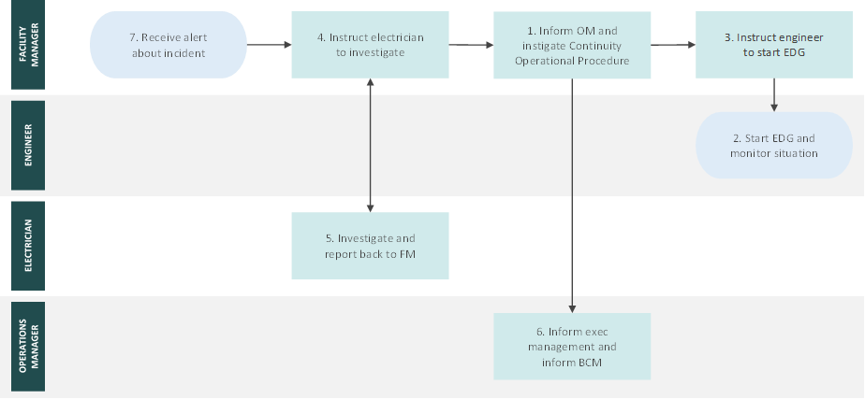
Figure 1 Example of a swim lane flowchart

Procedure steps table
[A table describing the steps in flow diagram clearly and identify the person responsible]
STEP | DESCRIPTION | RESPONSIBLE PERSON
- Receive alert about incident | Either a phone or email alert is received by the FM. The FM assesses the incident. | Facility Manager
- Instruct electrician to investigate | FM instructs the duty electrician to investigate the incident. | Facility Manager
- Investigate and report back to FM | Upon investigation, the duty electrician informs the FM of the situation and estimated time to repair (if possible). | Electrician  Facility Manager
- Inform OM and instigate continuity operational procedure | FM informs the OM of the incident, the results of the investigation and recommendations. Selecting the relevant Continuity Operation Procedure, instigates the steps within it. | Facility Manager
- Inform Exec Management and inform BCM | OM informs the executive management of the situation and estimated potential downtime. OM also states the response being taken by the Facilities Department staff. OM also informs the BCM of the incident and current response. | Operational Manager
- Instruct engineer to start EDG | FM instructs the duty engineer to start the Emergency Diesel Generator following the Work Instruction by the EDG. | Facility Manager
- Start EDG and monitor the situation | Duty engineer follows EDG start-up Work Instruction and informs FM when EDG is steady and ready to take the load. Duty engineer continues to monitor situation. | Engineer
Table 1 - Procedure steps table

Auditing and logging
[Specify the auditing and logging activities that need to be carried out, if not detailed in the body of the procedure. Does a paper form need to be completed? What audit records are kept by the system?]

Monitoring
[Describe how the activity is monitored if not detailed in the body of the procedure].

